A12 - User Manual

Year: 2025 Semester: Spring Team: 10 Project: Smart Card Shuffler

Creation Date: April 14, 2025 Last Modified: April 19, 2025

Author: Craig Eagleburger Email: ceaglebu@purdue.edu

Product Description

The Smart Card Shuffler is the card shuffling device of the future, providing more customizable and personal shuffling than was ever before possible. Using the Smart Card Shuffler and the Smart Card Shuffler app, you can quickly reorganize your deck of cards to suit your needs.

Your Smart Card Shuffler package should contain:

One fully assembled Smart Card Shuffler

One card collection tray

One standard 3-Prong power cable

One user manual

Product Illustrations

Shuffler
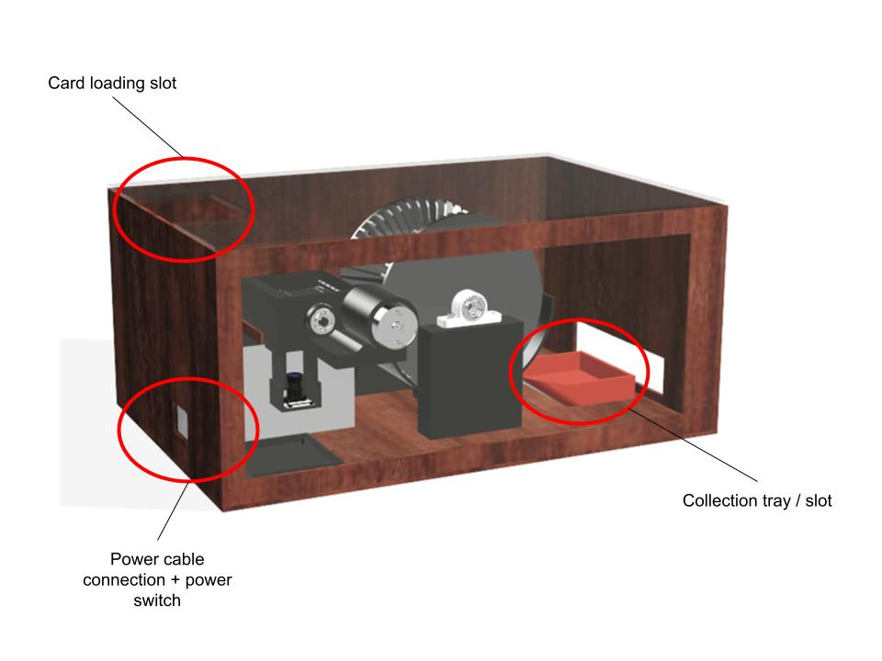

Application

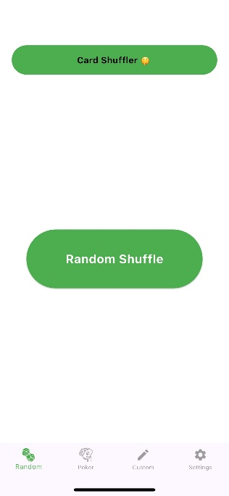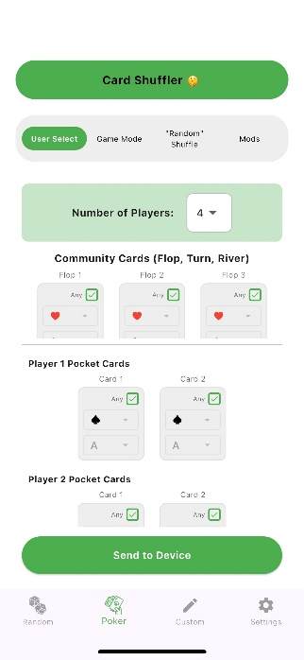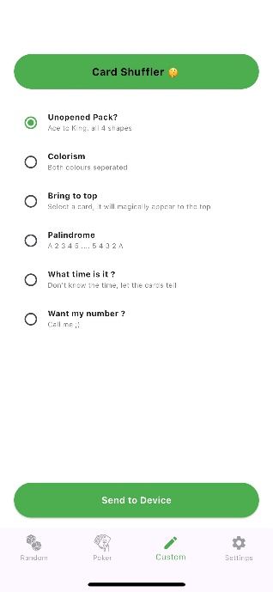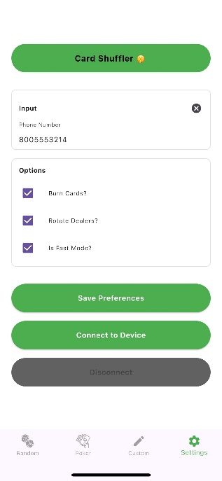

Setup Instructions

Device

Place the Smart Card Shuffler on a stable, balanced surface.

Insert the card collection tray in the card collection slot, ensuring it aligns with the interior wheel.

Insert the desired side panel (wood or clear acrylic) into the side of the device.

Ensure the power switch is set to the off position (circle).

Plug in the provided power cable into the wall and the back of the device.

Mobile Application

Download “Smart Card Shuffler” from your Apple or Android mobile device’s app store.

Open the application and select the settings tab.

Tap “Connect to Device” to connect to the device via Bluetooth.

Usage Instructions

Shuffle Configuration

Before starting the shuffler, a shuffle configuration must be uploaded from the mobile app. There are several different configurations to choose from:

Random Shuffle

Select the “Random” tab in the mobile app.

Press the “Random Shuffle” button to upload the configuration to the device.

Poker

There are several poker modes to choose from, each accessible from the “Poker” tab of the mobile app. Be sure to set your configuration in the settings tab – this affects things like rotating dealers, burning cards, and “Fast Mode”, which sacrifices some randomness for a faster shuffle.

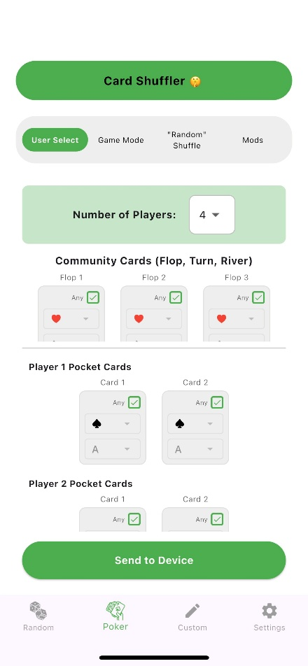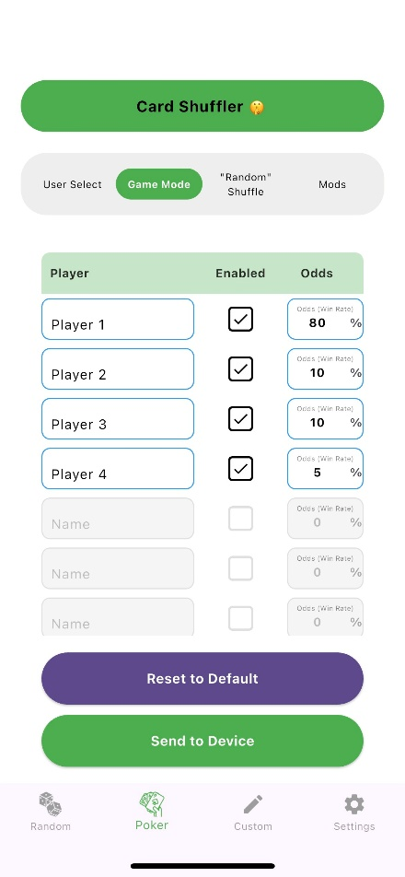

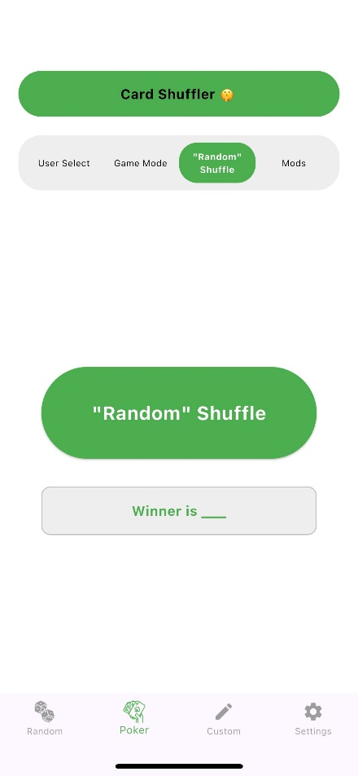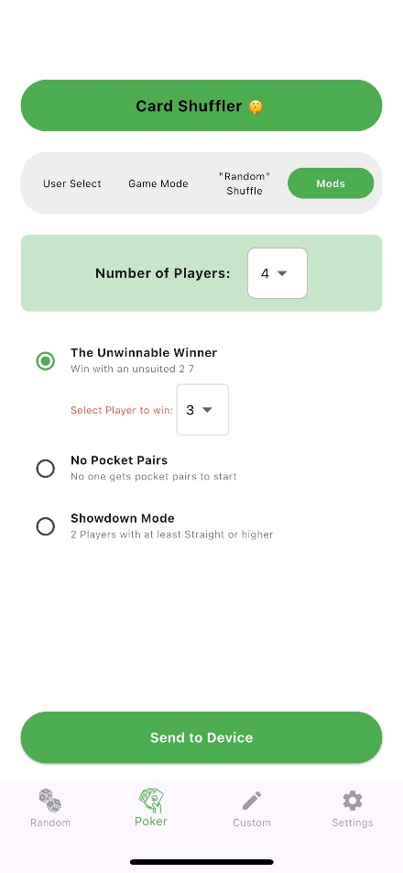

User Select – Use this to customize the exact hand each player will receive.

Select the number of players from the drop down.

For each card that you want to customize:

Uncheck its “Any” checkbox.

Select a suit and value from the drop-down menus.

All other cards will be randomly selected.

Press the “Send to Device” button to upload the configuration to the device.

Game Mode – Use this to assign win percentages to different players

For up to 8 players, check the “Enabled” box, and enter the desired Win Rate as a percentage.

Press the “Send to Device” button to upload the configuration to the device.

“Random” Shuffle – Use this for a random shuffle, but know which player will win.

Press the “Random Shuffle” button to upload the configuration to the device.

The winner will appear in the “Winner is ___” text box.

Mods – Use this for fun poker scenarios.

Select the number of players from the drop-down menu.

Select your desired mod (Unwinnable Winner, No Pocket Pairs, Showdown Mode).

Press the “Send to Device” button to upload the configuration to the device.

Custom

Select the custom mode you would like to use.

If necessary, select the parameters from the drop-down menu that appears.

Press the “Send to Device” button to upload the configuration to the device.

Starting Shuffle

Upload shuffle configuration device according to steps in the Shuffle Configuration section.

Insert cards (Bicycle, Jumbo lettering) face-down into the card feeder through the card loading slot.

Ensure card collection tray is in the proper position described in Setup.

Press the start button on the shuffler. You should hear the motors begin working to deliver your desired shuffle!

Keep an ear out for jams, and make sure to power the device off if necessary.

Collecting Cards

Wait until all cards have been dispensed.

Remove the card collection tray through the card collection slot.

The deck will be upside down, so be sure to hide the bottom card if necessary.

Remove the deck from the collection tray.

Replace the collection tray in its proper position described in Setup.

Enjoy!

Troubleshooting Instructions

Despite the efforts of team 10’s expert engineers, there is still a low chance that the Smart Card Shuffler will occasionally encounter problems. Here is a list of common issues and potential solutions:

Problem | Probable Causes | Solution Steps
Failed to find Bluetooth device. | Device is not receiving power  Device has been on for too long (several days) and needs to be restarted | Ensure the shuffler is plugged in and powered on.  Restart the device to refresh its Bluetooth services
My Smart Card Shuffler has jammed! | Cards not fully leaving feeder while entering wheel  Cards remaining stuck in wheel while dispensing | Immediately power off to prevent damage to cards  Ensure card collection tray is properly aligned  Remove lid and ensure card sorting wheel is free of debris in all slots
My cards are not being dispensed in the correct order! | Cards not being properly recognized by camera | Ensure use of Bicycle cards with jumbo print.  Ensure cards are being inserted face-down.

Still having trouble? Call our service desk at 1-800-SHUFFLE!

